RXNORM

Create a lambda function and add a code

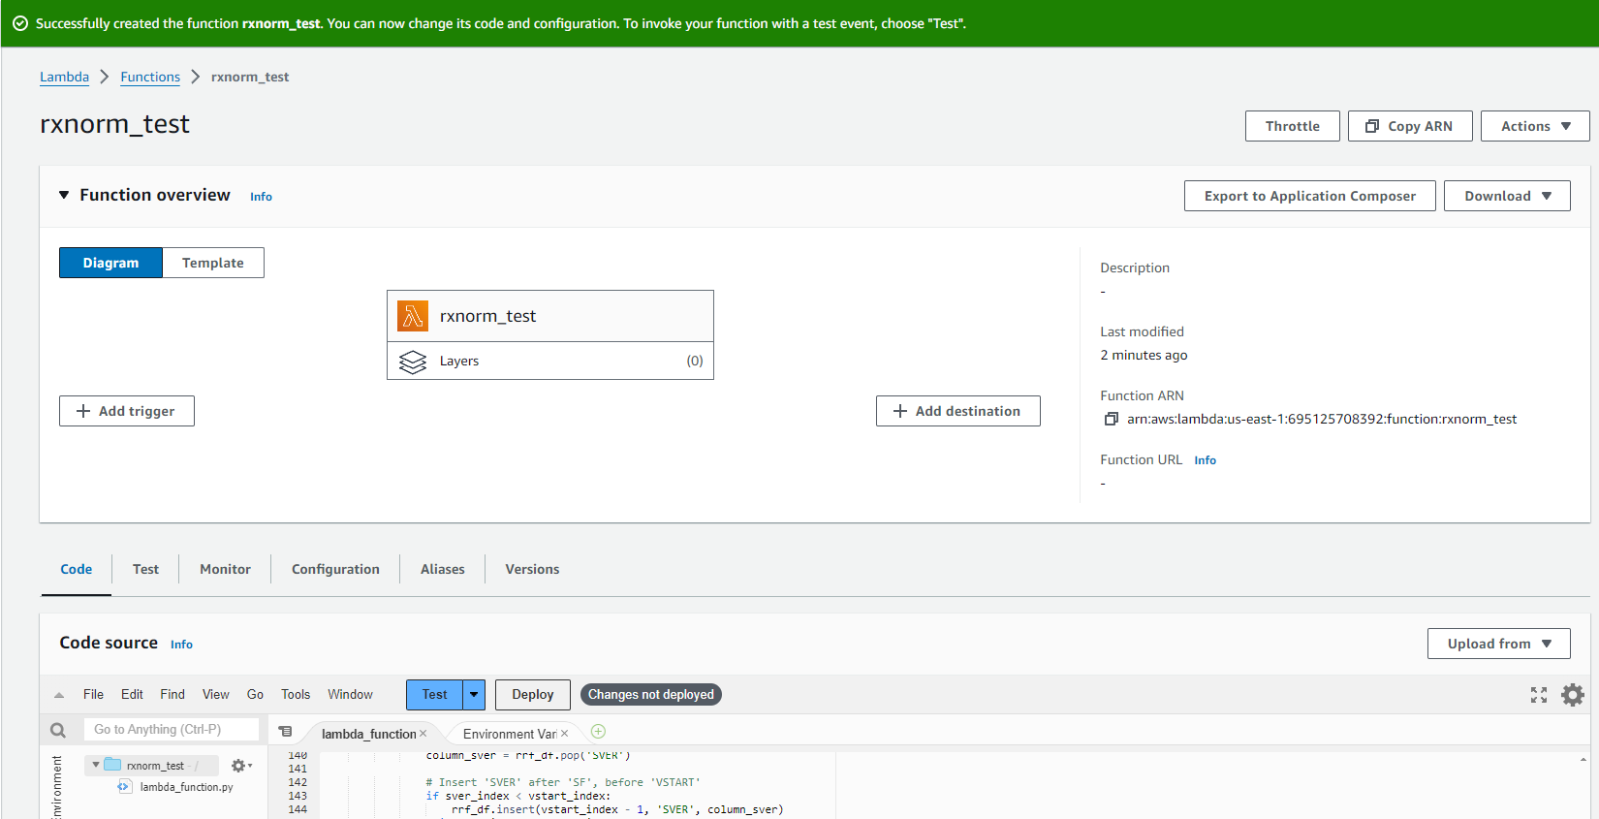

Then create a S3 bucket

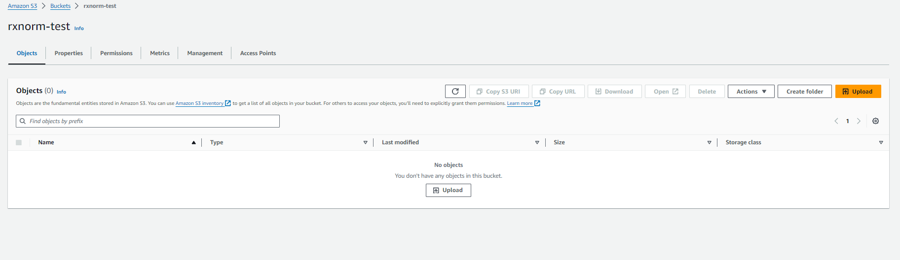

Then create 4 folders

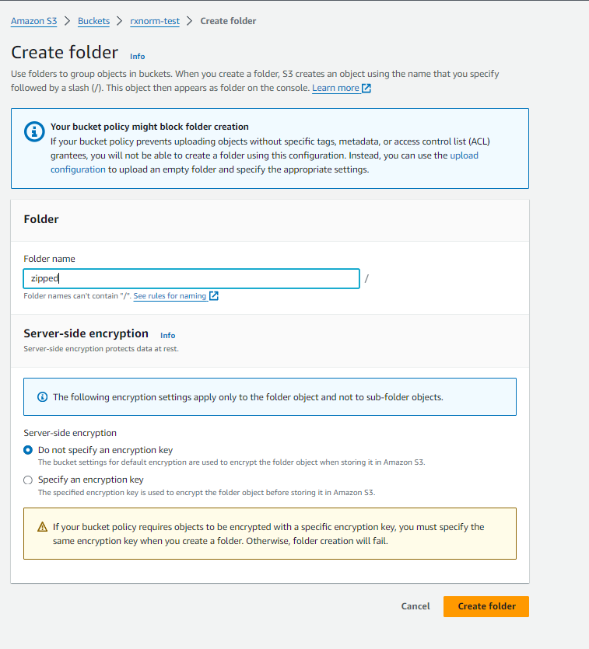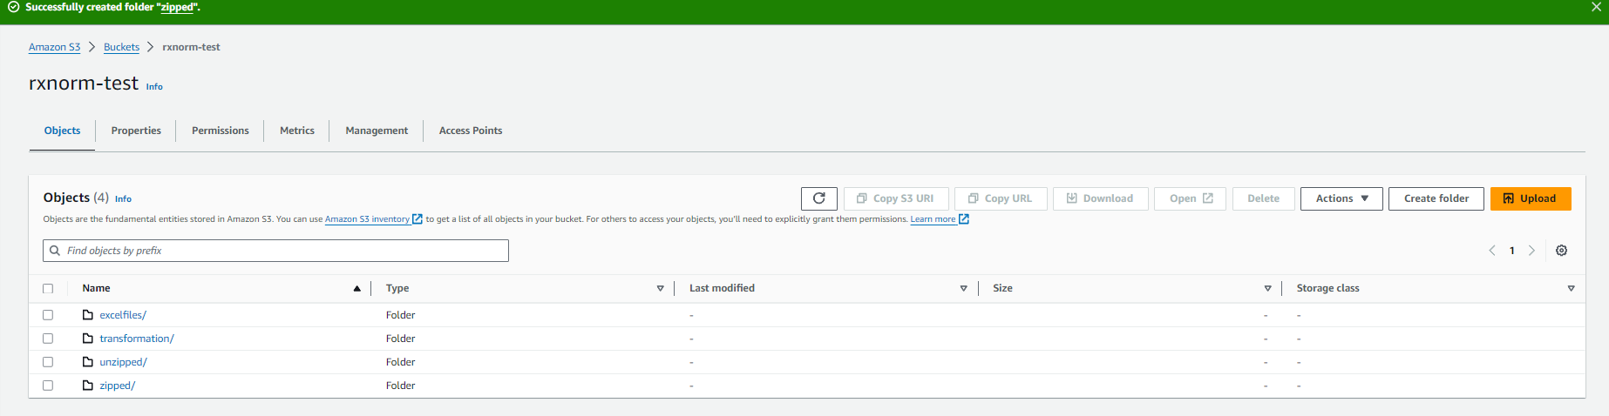

Uploading Header file in excel folder

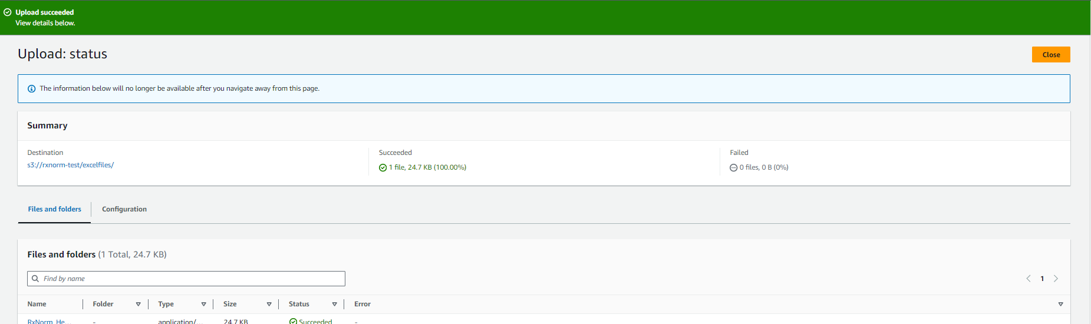

Uploading RXNorm zipped file in Zipped folder

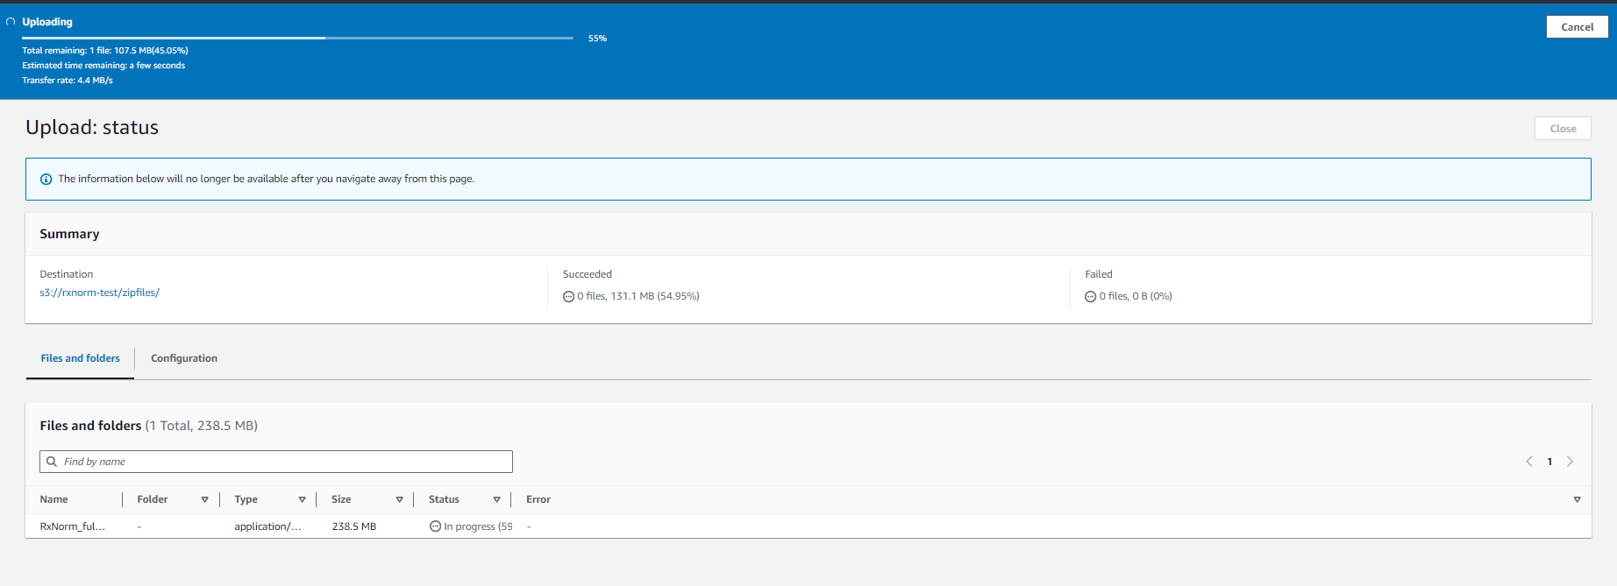

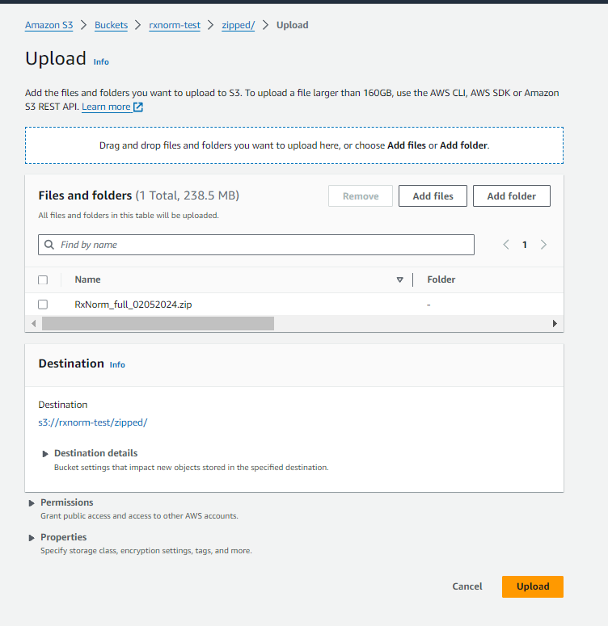

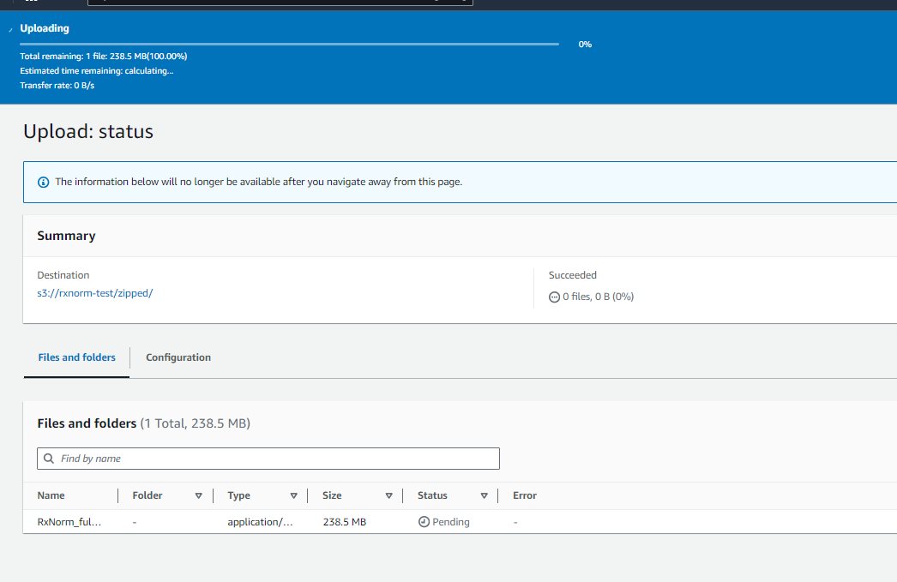

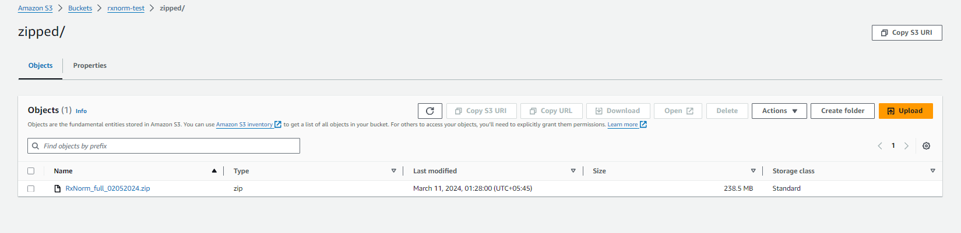

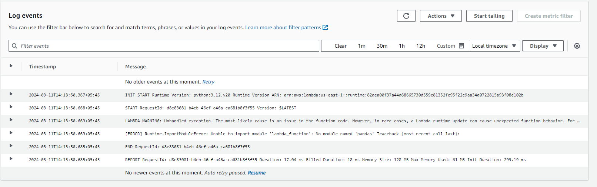

We must import pandas by creating a layer

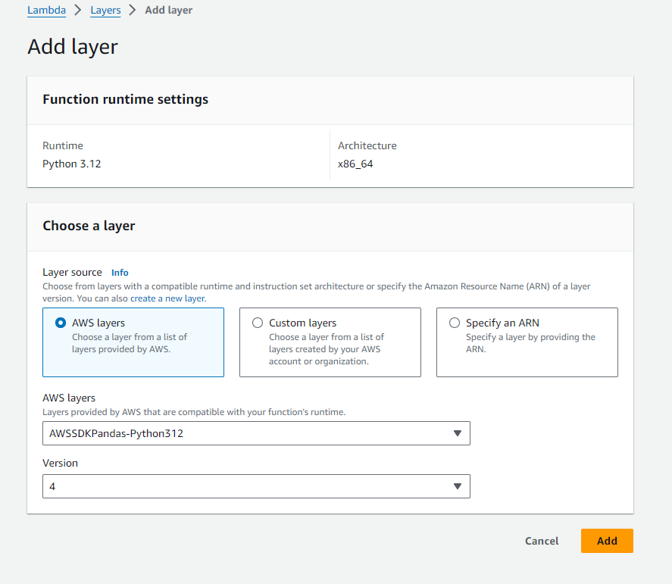

It gives me error because of high storage file and low memory in AWS. Also because of time out so we change some settings

